**Charity Campaigns Application**

**Use Case Specifications**

**Project Code: TCS**

**Document Code: SRS_CAL_WEBAPP_MasterPage _v0.1**

**Ha Noi**

**RECORD OF CHANGE**

*A - Added M - Modified D - Deleted

| **Effective Date** | **Changed Items** | **A* M, D** | **Change Description** | **New Version** |
| --- | --- | --- | --- | --- |
| 06-Nov-08 |  | A | First created | 1.0 |
| 11-Nov-08 |  | M | Changes after first review from CIE | 1.1 |
|  |  |  |  |  |
|  |  |  |  |  |
|  |  |  |  |  |
|  |  |  |  |  |
|  |  |  |  |  |
|  |  |  |  |  |
|  |  |  |  |  |
|  |  |  |  |  |
|  |  |  |  |  |
|  |  |  |  |  |
|  |  |  |  |  |
|  |  |  |  |  |
|  |  |  |  |  |
|  |  |  |  |  |
|  |  |  |  |  |
|  |  |  |  |  |
|  |  |  |  |  |
|  |  |  |  |  |
|  |  |  |  |  |

**SIGNATURE PAGE**

**ORIGINATOR:** 29-Oct-08

Team leader

**REVIEWERS:** 06-Nov-08

PTL

06-Nov-08

**APPROVAL:**

**TABLE OF CONTENTS**

**1** **INTRODUCTION 5**

1.1 Purpose 5

1.2 Scope 5

1.3 Definitions, Acronyms, and Abbreviations 5

1.4 References 5

**2** **HIGH LEVEL REQUIREMENTS 6**

2.1 Business Essence 6

2.2 High level use case 7

2.3 Use cases diagrams 8

**3** **SPECIFIC REQUIREMENTS 10**

3.1 Functionality 10

3.2 Data field valid conditions 76

**4** **NON FUNCTIONAL SPECIFICATION 78**

4.1 Usability 78

4.2 Reliability 78

4.2.1 Availability 78

4.2.2 System Dependencies 78

4.2.3 Bugs and Defect Rates 78

4.3 In SDC process, there are four bug severities. Each severity has a weighted value as in table below: 78

4.4 Performance 80

4.5 Supportability 80

1. **INTRODUCTION**
   1. ***Purpose***

CharityCampainsApplication Use Case Specifications document is the complete and comprehensive description of software requirement. This system is a .Net based application, which performs various functions on the User and Admin functions.

This document will be the basic for further analysis and design model.

* 1. ***Scope***

The scope of this project:

+ Planning, Studying requirement, Designing, Coding and Testing.

* 1. ***Definitions, Acronyms, and Abbreviations***

| No | Abbreviations | Description |
| --- | --- | --- |
| 1 |  |  |
| 2 |  |  |

* 1. ***References***

EXAMPLE Standard 07-08.pdf

EXAMPLE CIE Pricing Database.xls

Project Brief.doc

1. **HIGH LEVEL REQUIREMENTS**
   1. ***Business Essence***

Main functions of system are listed as following:

+ View campaign list

+ Create/Update campaign

+ View Donation History

+ View Danator List

+ View List Campaign

+ View Detail Campaign

* 1. ***High level use case***

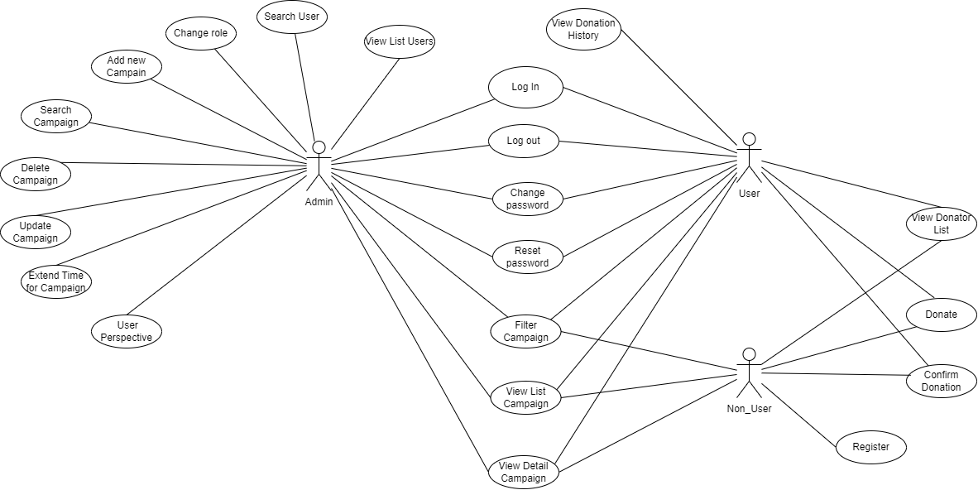

*High-level use case*

* 1. ***Use cases diagrams***
     1. **Actor description**

| **#** | **Actor** | **Description** |
| --- | --- | --- |
| 1 | Admin | Can manage charity campaign, manage user |
| 2 | User | Can view view campaign, donate, history |
| 3 | Non_User | Can view view campaign, donate |

* + 1. **Use case description**

| **#** | **Code** | **Name** | **Brief Description** |
| --- | --- | --- | --- |
| 1 | UC01 | Log In | Allows user to log in |
| 2 | UC02 | Log out | Allows user to log out |
| 3 | UC03 | Change password | Allows user to change password |
| 4 | UC04 | Reset password | Allows user to reset password |
| 5 | UC05 | Register | Allows user to register |
| 6 | UC06 | View List Users | Allows administrator to view list users |
| 7 | UC07 | Search User | Allows administrator to search users |
| 8 | UC08 | Change role | Allows administrator to change other user’s role to admin and revert |
| 9 | UC09 | Add new Campaign | Allows administrator to add new donation campaign |
| 10 | UC10 | Search Campaign | Allows user to search donation campaign through campaign code and phone number |
| 11 | UC11 | Delete Campaign | Allows administrator to delete campaign that has “just created” status |
| 12 | UC12 | Update Campaign | Allows administrator to update campaign that has “closed campaign” status |
| 13 | UC13 | Extend Time for Campaign | Allows administrator extend time for campaign that has “Donating” status |
| 14 | UC14 | User Perspective | Allows administrator to view campaigns as “User” perspective |
| 15 | UC15 | Filter Campaign | Allows user filter charities list according to status |
| 16 | UC16 | View List Campaign | Allows user to view list of charity campaigns |
| 17 | UC17 | View Detail Campaign | Allows user to view detail information of a campaign |
| 18 | UC18 | Donate | Allows user to donate for a campaign |
| 19 | UC19 | Confirm Donation | Allows user to confirm after making a transfer |
| 20 | UC20 | View Donator List | Allows user to view list of donator in a campaign |
| 21 | UC21 | View Donation History | Allows user to view their donation history |

* 1. ***Screens***
     1. **Screen flow**

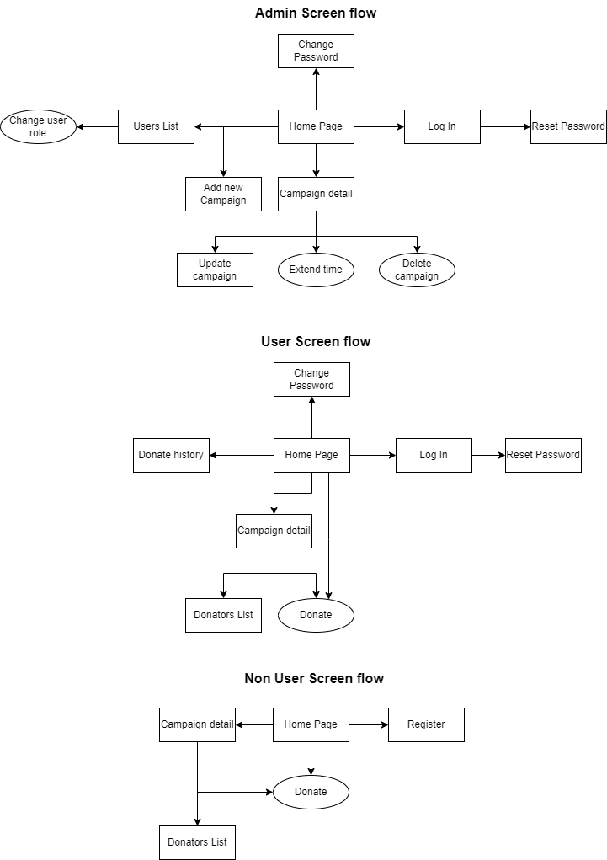

* + 1. **Screen description**

| **#** | **Screen name** | **Brief Description** |
| --- | --- | --- |
| 1 | Home Page | Allow user to view list campaign |
| 2 | Log In | Allows user to log in |
| 3 | Reset Password | Allows user to reset password |
| 4 | Change Password | Allows user to change password |
| 5 | Register | Allows user to register account |
| 6 | Users List | Allows administrator to manage users list |
| 7 | Change user role | Allows administrator to change “User” role |
| 8 | Campaign detail | Allows user to view detail in one charity campaign |
| 9 | Add new Campaign | Allows administrator to add a new charity campaign |
| 10 | Update campaign | Allows administrator to update detail for a charity campaign |
| 11 | Extend time | Allows administrators to extend time for a charity campaign. |
| 12 | Delete campaign | Allows administrator to delete a charity campaign |
| 13 | Donators List | Allows user to view donator list |
| 14 | Donate | Allows user to donate for a charity campaign |
| 15 | Donate history | Allows user to view their donate history |

1. **SPECIFIC REQUIREMENTS**
   1. ***Functionality***
      1. **UC01: Login**
2. **Screen Layout**

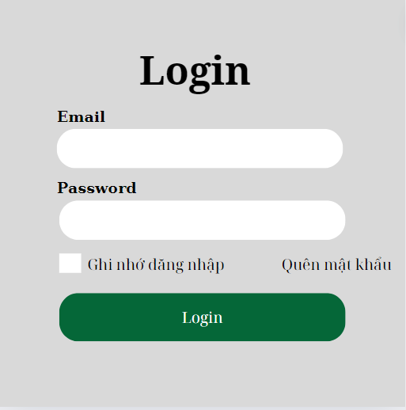

*Figure 1. “Login” screen*

| **Field Name** | **Field Type** | **Description** |
| --- | --- | --- |
| Email* | Text Box | This is for the user to input their username |
| Password* | Password Box | This is for the user to input their password |
| Login | Button | This is for user sign-in to the system |

1. **UC Specification**

##### 

| Use Case Name | **UC-1_Log In** | | | | |
| --- | --- | --- | --- | --- | --- |
| Primary Actor | Admin, User | | Secondary Actor: | | Google API |
| Precondition | PRE-1: The user needs to access the system.  PRE-2: The user's device is connected to the internet.  PRE-3: The user has registered their account to the system. | | | | |
| Postcondition | POST-1: The system displays the Homepage with an account. | | | | |
| Description: | The “Log in” use case enables users with an account in the system to access all system features, such as an admin, patient, accountant, doctor, nurse, or receptionist. | | | | |
| Normal Flow | **UC-1.0_Log In** | | | | |
| **Step** | **Actor** | | **System** | |
| **1** | The user clicks on the “Đăng nhập” button on the navbar. | | The system displays a “Đăng nhập” popup. | |
| **2** | The user fills in the Log-in form or chooses another Sign-in option (2.2). | |  | |
| **3** | User clicks on “Đăng nhập” button. | | The system verifies the user’s login information and then redirects it to the homepage. | |
| Exceptions: | **1.0.E1 In step 2, If the user does not enter “Tên đăng nhập”**  => Display message:  **1.0.E2 In step 2, If the user does not enter “Mật khẩu”**  => Display message:  **1.0.E3 In step 3, If the user enters the wrong login information**  => Display message: | | | | |

* + 1. **UC2: Log out**

1. **UC Specification**

##### 

| Use Case Name | **UC-1_Log Out** | | | | |
| --- | --- | --- | --- | --- | --- |
| Primary Actor | All User | | Secondary Actor: | | Google API |
| Precondition | PRE-1: The user needs to access the system.  PRE-2: The user's device is connected to the internet.  PRE-3: The user has registered their account to the system. | | | | |
| Postcondition | POST-1: The system displays the Homepage with an account. | | | | |
| Description: | The "Sign out" use case enables users to terminate their session and end their interaction with the system, effectively logging them out and ensuring the security of their account and data. | | | | |
| Normal Flow | **UC-1.0_Log Out** | | | | |
| **Step** | **Actor** | | **System** | |
| **1** | The user clicks on the “Đăng xuất” button on the navbar. | | The system verifies the user’s log-out information and then redirects it to the homepage. | |
| Exceptions: |  | | | | |

* + 1. **UC03: Reset Password**

1. **Screen Layout**

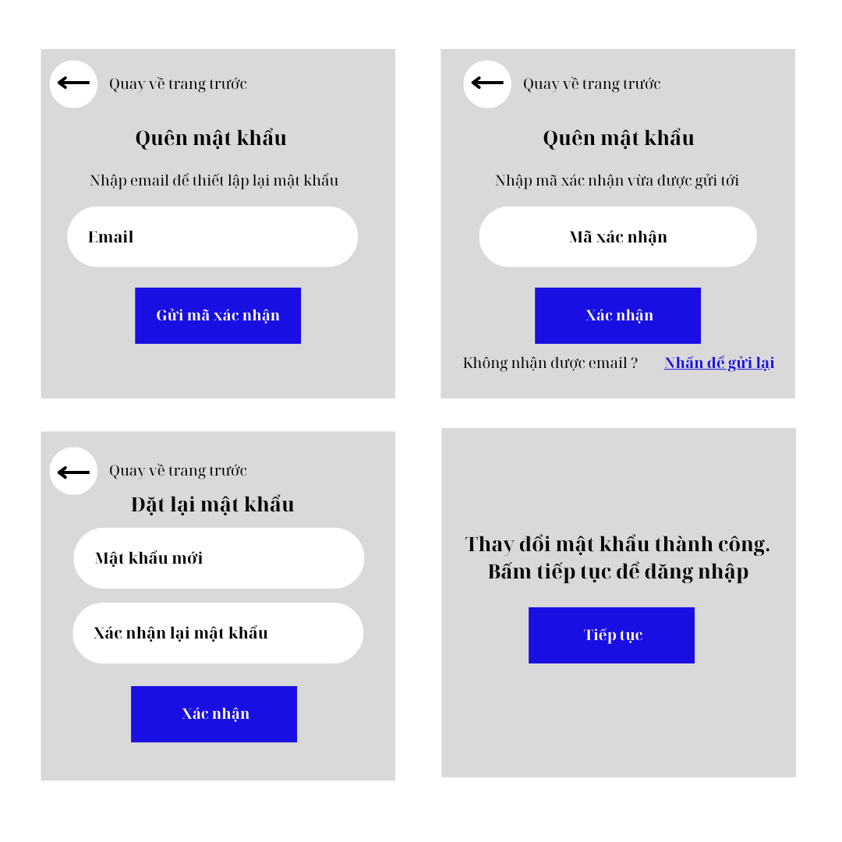

*Figure 04: “Reset password” screen*

| **Field Name** | **Field Type** | **Description** |
| --- | --- | --- |
| Email* | Text Box | This is for a user to input a valid email to send verify code email |
| Gửi email | Button | This is for a user to input to received verify code email |
| Quay về trang trước | Button | This is for a user to go to the last step |
| Gửi mã xác nhận | Button | This is for the system to send verified code mail to a user |
| Nhập mã xác nhận* | Text box | This is for a user to input the received verify code |
| Nhấn để thử lại | Button | If the user doesn’t receive any email, click this button to resend |
| Xác nhận | Button | Click this button to go to the next step if the user inputted the correct verification code |
| Mật khẩu mới* | Password Box | This is for a user to input a valid password for login |
| Xác nhận lại mật khẩu* | Password Box | This is for a user to re-enter the password for signing up |
| Đặt lại mật khẩu | Button | Click this button to reset your password |

1. **UC Specification**

##### 

| Use Case Name | **UC-3_Reset Password** | | | | |
| --- | --- | --- | --- | --- | --- |
| Primary Actor | Admin, User | | Secondary Actor | | Google API |
| Precondition | PRE-1: The user needs to access the system and is currently on the sign-in page  PRE-2: The user's device is connected to the internet  PRE-1: The user’s account exists in the database. | | | | |
| Postcondition | POST-1: The old password of the account has been changed to the new one, the user can now access the system with their new password. | | | | |
| Description: | The use case "Reset Password" allows users to regain access to the system if they have forgotten their password by enabling them to create a new password for themselves. | | | | |
| Normal Flow | **UC-3.0_Reset Password** | | | | |
| **Step** | **Actor** | | **System** | |
| **1** | The user clicks on “Quên mật khẩu” on Sign In screen | | System displays “Quên mật khẩu” screen | |
| **2** | The user inputs their email and then clicks the “Gửi mã xác nhận” button | | The system sends verify code to the user’s email and displays the “Nhập mã xác nhận” screen | |
| **3** | The user inputs verify code, then clicks the “Xác nhận” button | | System displays “Đặt lại mật khẩu” screen | |
| **4** | The user inputs a new password, then re-inputs a new password, then clicks the “Xác nhận” button | | System notifies “Thay đổi mật khẩu thành công” | |
| Alternative Flows | **UC-3.1_Resend verify code** | | | | |
| **Step** | **Actor** | | **System** | |
| **1** | The user clicks on “Quên mật khẩu” on Sign In screen | | System displays “Quên mật khẩu” screen | |
| **2** | The user inputs their email, and then clicks the “Gửi mã xác nhận button” | | The system sends verify code to the user’s email and displays the “Nhập mã xác nhận” screen | |
| **3** | User clicks “Gửi lại mã’ button | | The system sends verify code to the user’s email | |
| **4** | Return to step 3 of normal flow | |  | |
| Exceptions: | N/A | | | | |
| Business Rules: | N/A | | | | |

#### 

* + 1. **UC04: Regisster**

1. **Screen Layout**

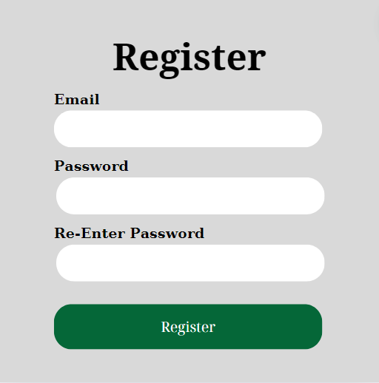

*Figure 05a: “Register” screen*

| **Field Name** | **Field Type** | **Description** |
| --- | --- | --- |
| Email* | Text Box | This is for the user to input their username |
| Password* | Password Box | This is for the user to input their password |
| Re-Enter Password | ReEnter  Password | This is for the user to input their confirm password |
| Login | Button | This is for user sign-in to the system |

1. **UC Specification**

##### 

| Use Case Name | **UC-4_Register** | | | | |
| --- | --- | --- | --- | --- | --- |
| Primary Actor | Non User | | Secondary Actor: | | Google API |
| Precondition | PRE-1: User does not have an account to log in to the system. | | | | |
| Postcondition | POST-1: The system displays the Homepage. | | | | |
| Description: | The “Register” use case enables users can register an account in the system to access all system features. | | | | |
| Normal Flow | **UC-1.4_Register** | | | | |
| **Step** | **Actor** | | **System** | |
| **1** | The user clicks on the “Đăng Kí” button on the navbar. | | The system displays a “Đăng Kí” popup. | |
| **2** | The user fills in the Log-in form or chooses another Register option (2.2). | |  | |
| **3** | User clicks on “Đăng kí” button. | | The system verifies the user’s login information and then redirects it to the homepage. | |
| Exceptions: | **1.0.E1 In step 2, If the user does not enter “Tên đăng nhập”**  => Display message:  **1.0.E2 In step 2, If the user does not enter “Mật khẩu”**  => Display message:  **1.0.E3 In step 3, If the user enters the wrong login information**  => Display message: | | | | |

* + 1. **UC05: Change Password**

1. **Screen Layout**

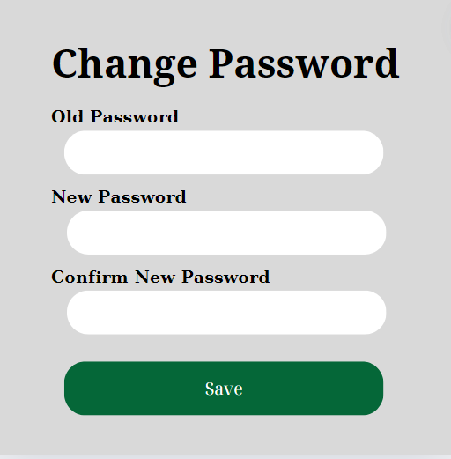

*Figure 06: “Change Password” screen*

| **Field Name** | **Field Type** | **Description** |
| --- | --- | --- |
| Old Password* | Text Box | This is for the user to input their old password |
| New Password* | Text Box | This is for the user to input their new password |
| Confirm New Password | Text Box | This is for the user to input their confirm new password |
| Save | Button | This is for user save password |

1. **UC Specification**

##### 

| Use Case Name | **UC-5_Change Password** | | | | |
| --- | --- | --- | --- | --- | --- |
| Primary Actor | Admin, User | | Secondary Actor: | | Google API |
| Precondition | PRE-1: The user needs to access the system.  PRE-2: The user's device is connected to the internet.  PRE-3: The user has registered their account to the system. | | | | |
| Postcondition | POST-1: The system displays the Homepage with an account. | | | | |
| Description: | The “Change Password” use case enables users with an account can change the password into the system. | | | | |
| Normal Flow | **UC-5.0_Change Password** | | | | |
| **Step** | **Actor** | | **System** | |
| **1** | The user clicks on the “Change password” button on the profile dropdown. | | The system displays a “Đổi mật khẩu” popup. | |
| **2** | The user fills in the Change password form (2.2). | |  | |
| **3** | User clicks on “Save” button. | | The system verifies the user’s change password information and then redirects it to the profile. | |
| Exceptions: |  | | | | |

* + 1. **UC06: User List**

1. **Screen Layout**

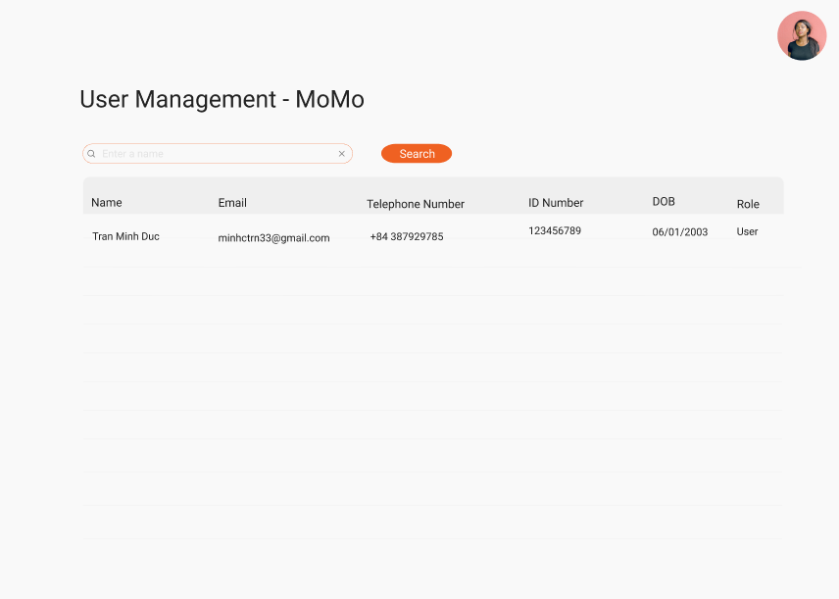

*Figure 07: “User List” screen*

| **Field Name** | **Field Type** | **Description** |
| --- | --- | --- |
| Search | Input | This is for an administrator to enter the user’s full name |
| Search Button | Button | This is for an administrator to search by the name entered in the search input box |
| User List | Table | This is for an administrator to view all the user’s information |
| User Role | Select | This is for the administrator to modify the role of a user |

##### 

1. **UC Specification**

#### 

##### 

| Use Case Name | **UC-6_View User List** | | | | |
| --- | --- | --- | --- | --- | --- |
| Primary Actor | Admin | |  | |  |
| Precondition | PRE-1: The administrator needs to access user management page | | | | |
| Postcondition | POST-1: The user management page has to display all the features. | | | | |
| Description: | The use case "User List" allows administrator to list all user in the list and display all the information in the table below the search bar | | | | |
| Normal Flow | **UC-6.0_View User List** | | | | |
| **Step** | **Actor** | | **System** | |
| **1** | Users login to the system  User clicks “User” on the sidebar | | Navigate users to the “List User” screen and show all User that exists in the system | |
| Alternative Flows | N/A | | | | |
| Exceptions: | N/A | | | | |
| Business Rules: | N/A | | | | |

#### 

* + 1. **UC07: Search User**

1. **Screen Layout**

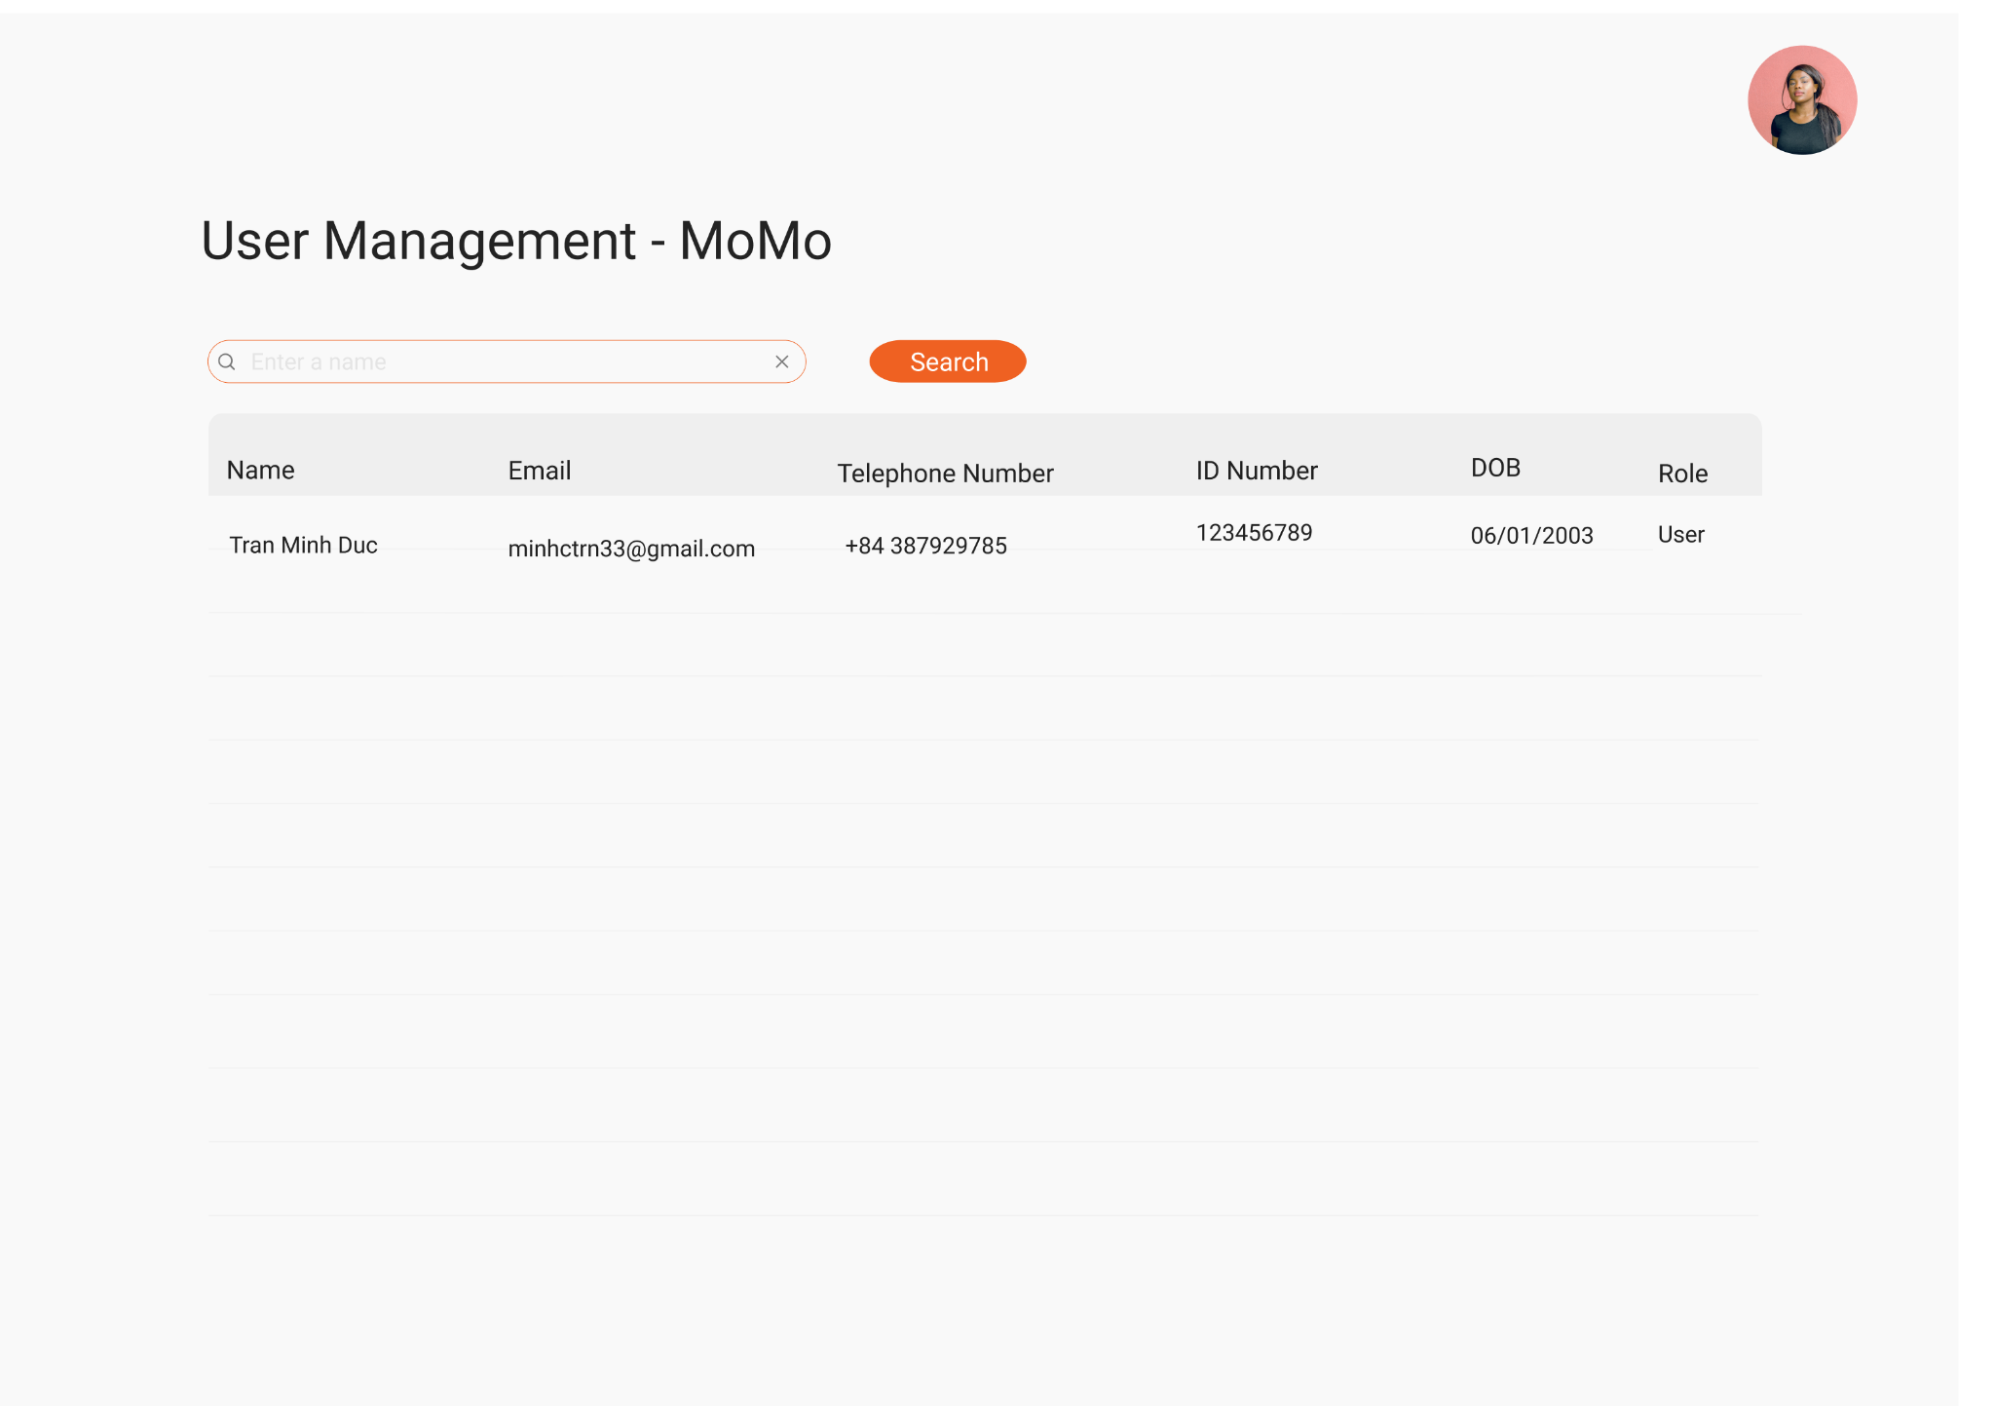

*Figure 10: “User Search” screen*

1. **UC Specification**

| **Field Name** | **Field Type** | **Description** |
| --- | --- | --- |
| Search | Input | This is for a administrator to enter user’s fullname |
| Search Button | Button | This is for a administrator to search by the name entered in the search input box |
| User List | Table | This is for a administrator to view all the user’s information |
| User Role | Select | This is for the administrator to modify the role of an user |

##### 

| Use Case Name | **UC-3_User Search** | | | | |
| --- | --- | --- | --- | --- | --- |
| Primary Actor | Admin | |  | |  |
| Precondition | PRE-1: The administrator needs to access user management page | | | | |
| Postcondition | POST-1: The user management page has to display all the features. | | | | |
| Description: | The use case "User Search" allows administrator to search an user in the list by their fullname and display all the information in the table below the search bar | | | | |
| Normal Flow | **UC-3.0_User Search** | | | | |
| **Step** | **Actor** | | **System** | |
| **1** | The administrator access to the user management page | | System displays “user management page” screen | |
| **2** | The administrator input a name in the search bar | |  | |
| **3** | The administrator click on search button | | The system execute the search function and show the result on the interface | |
| Alternative Flows | N/A | | | | |
| Exceptions: | N/A | | | | |
| Business Rules: | N/A | | | | |

#### 

* + 1. **UC08: Change Role**

1. **Screen Layout**



*Figure 04: “Change Role” screen*

1. **UC Specification**

| **Field Name** | **Field Type** | **Description** |
| --- | --- | --- |
| Search | Input | This is for a administrator to enter user’s fullname |
| Search Button | Button | This is for a administrator to search by the name entered in the search input box |
| User List | Table | This is for a administrator to view all the user’s information |
| User Role | Select | This is for the administrator to modify the role of an user |

##### 

| Use Case Name | **UC-3_Change Role** | | | | |
| --- | --- | --- | --- | --- | --- |
| Primary Actor | Admin | |  | |  |
| Precondition | PRE-1: The administrator needs to access user management page | | | | |
| Postcondition | POST-1: The user management page has to display all the features. | | | | |
| Description: | The use case "Change Role" allows administrator to change the role of an user in the user list | | | | |
| Normal Flow | **UC-3.0_Change Role** | | | | |
| **Step** | **Actor** | | **System** | |
| **1** | The administrator access to the user management page | | System displays “user management page” screen | |
| **2** | The administrator choose the an user to change the role | | The system execute the change role function | |
| Alternative Flows | N/A | | | | |
| Exceptions: | N/A | | | | |
| Business Rules: | N/A | | | | |

#### 

* + 1. **UC09: Add New Campaign**

1. **Screen Layout**

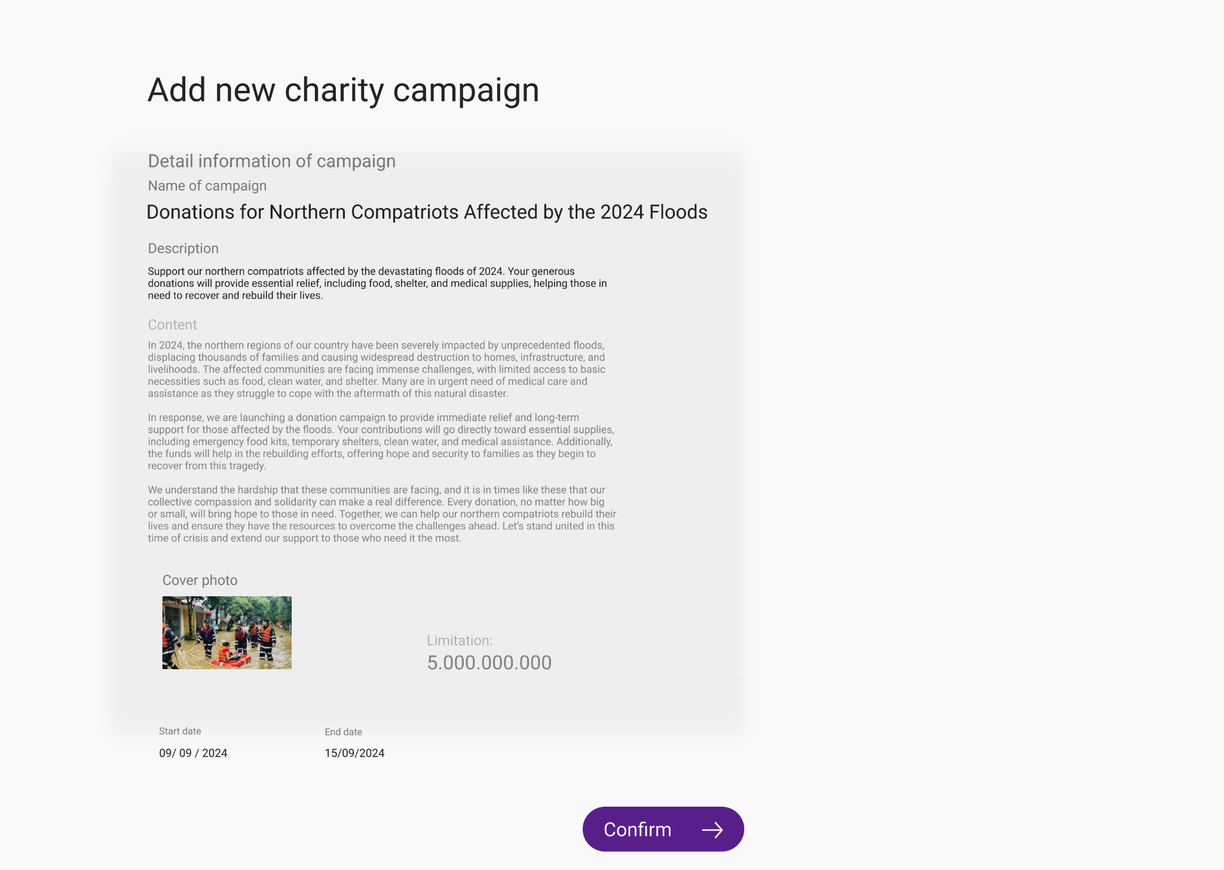

1. **UC Specification**

| **Field Name** | **Field Type** | **Description** |
| --- | --- | --- |
| Campaign Name Box | Input | This is for a administrator to enter campaign’s name |
| Description Box | Input | This is for a administrator to enter campaign’s description |
| Content Box | Input | This is for a administrator to enter campaign’s detail content |
| Photo Box | Input | This is for a administrator to enter campaign’s cover photo |
| Limitation Box | Input | This is for a administrator to enter campaign’s limitation |
| Start Date Box | Input | This is for a administrator to enter campaign’s start date |
| End Date Box | Input | This is for a administrator to enter campaign’s end date |
| Confirm Button | Button | This is for a administrator to confirm create the campaign |

##### 

| Use Case Name | **UC-3_Add New Campaign** | | | | |
| --- | --- | --- | --- | --- | --- |
| Primary Actor | Admin | |  | |  |
| Precondition | PRE-1: The administrator needs to access Add Campaign page | | | | |
| Postcondition | POST-1: The Add Campaign page has to display all the features. | | | | |
| Description: | The use case "Add Campaign" allows administrator to create a new charity campaign | | | | |
| Normal Flow | **UC-3.0_Add New Campaign** | | | | |
| **Step** | **Actor** | | **System** | |
| **1** | The administrator access to the Add Campaignt page | | System displays “Add Campaign page” screen | |
| **2** | The administrator add a name for campaign | |  | |
| **3** | The administrator add a description for campaign | |  | |
| **4** | The administrator addcontent for campaign | |  | |
| **5** | The administrator add cover photo for campaign | |  | |
| **6** | The administrator add limitation for campaign | |  | |
| **7** | The administrator add start date for campaign | |  | |
| **8** | The administrator add enddate for campaign | |  | |
| **9** | The administrator click on confirm button | | the system exucaute the create new campaign function | |
| Alternative Flows | N/A | | | | |
| Exceptions: | N/A | | | | |
| Business Rules: | N/A | | | | |

#### 

* + 1. **UC10: Search Campaign**

1. **Screen Layout**

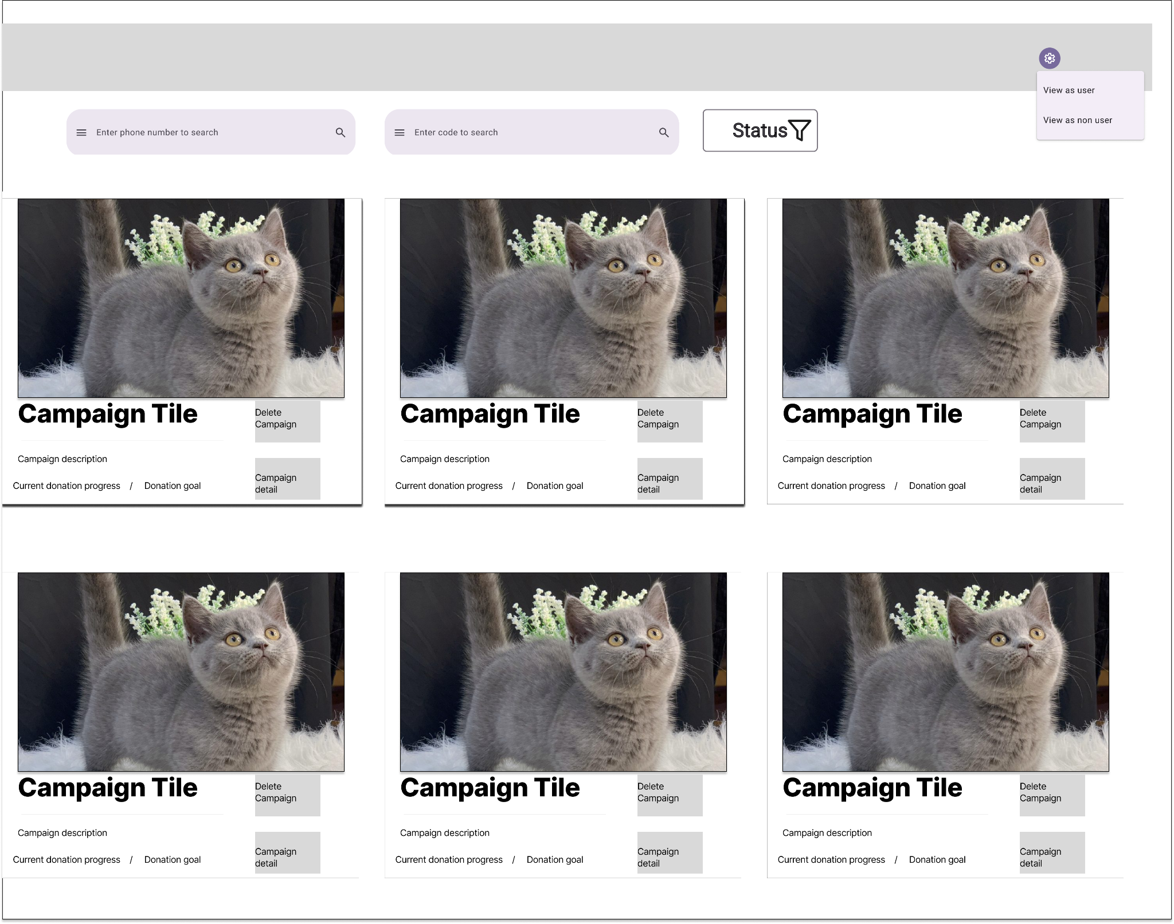

1. **UC Speccitfication**

| **Field Name** | **Field Type** | **Description** |
| --- | --- | --- |
| Phone Number Search Box | Input | This is for a administrator to enter phone numbert |
| Code Search Box | Input | This is for a administrator to enter campaign’s code |
| Status | Dropdown Button | This is for a administrator to enter campaign’s edit the status of campaign |
| Campaign List | Table | This is for a administrator to see full campaign list |
| Delete Campaign Button | Button | This is for a administrator to delete a campaign |
| Campaign Detail Button | Button | This is for a administrator view the detail of campaign |

##### 

| Use Case Name | **UC-3_Search Campaign** | | | | |
| --- | --- | --- | --- | --- | --- |
| Primary Actor | Admin | |  | |  |
| Precondition | PRE-1: The administrator needs to access Add Campaign page | | | | |
| Postcondition | POST-1: The Add Campaign page has to display all the features. | | | | |
| Description: | The use case "Add Campaign" allows administrator to create a new charity campaign | | | | |
| Normal Flow | **UC-3.0_Search Campaign** | | | | |
| **Step** | **Actor** | | **System** | |
| **1** | The administrator access to the Campaign List page | | System displays “Campaign List page” screen | |
| **2** | The administrator input a phone number or code into the search bar | |  | |
| **3** | The administrator click on search button | | The system execute the search function and show the result on the interface | |
| Alternative Flows | N/A | | | | |
| Exceptions: | N/A | | | | |
| Business Rules: | N/A | | | | |

#### 

* + 1. **UC11: Delete Campaign**

1. **Screen Layout**



1. **UC Speccitfication**

| **Field Name** | **Field Type** | **Description** |
| --- | --- | --- |
| Phone Number Search Box | Input | This is for a administrator to enter phone number |
| Code Search Box | Input | This is for a administrator to enter campaign’s code |
| Status | Dropdown Button | This is for a administrator to enter campaign’s edit the status of campaign |
| Campaign List | Table | This is for a administrator to see full campaign list |
| Delete Campaign Button | Button | This is for a administrator to delete a campaign |
| Campaign Detail Button | Button | This is for a administrator view the detail of campaign |

##### 

| Primary Actor | Admin | |  | |  |
| --- | --- | --- | --- | --- | --- |
| Precondition | PRE-1: The administrator needs to access Add Campaign page | | | | |
| Postcondition | POST-1: The Add Campaign page has to display all the features. | | | | |
| Description: | The use case "Add Campaign" allows administrator to create a new charity campaign | | | | |
| Normal Flow | **UC-3.0_Search Campaign** | | | | |
| **Step** | **Actor** | | **System** | |
| **1** | The administrator access to the Campaign List page | | System displays “Campaign List page” screen | |
| **2** | The administrator click on delete button | | The system execute the delete function and show the result on the interface | |
| Alternative Flows | N/A | | | | |
| Exceptions: | N/A | | | | |
| Business Rules: | N/A | | | | |

#### 

* + 1. **UC12: Update campaign**

1. **Screen layout**

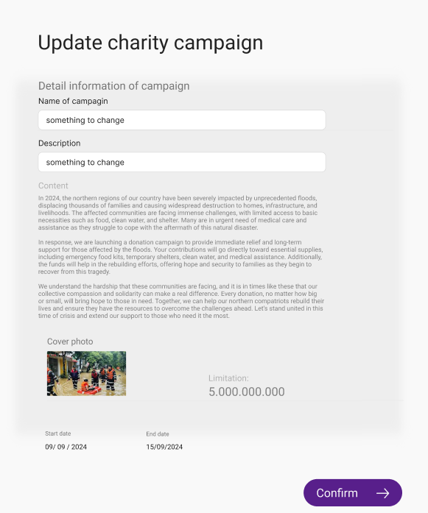

| **Field Name** | **Field Type** | **Description** |
| --- | --- | --- |
| Name of campaign | Text Box | This is for the user to input new campaign name to edit |
| Description | Text Box | This is for the user to input new campaign description to edit |
| Content | Textarea | This is for the user to input new campaign content to edit |
| Cover photo | File select | This is for the user to input new campaign cover photo to edit |
| Limitation | Number | This is for the user to input new campaign limitation to edit |
| Confirm | Button | A button to confirm and update information |

1. **UC Specification**

| Use Case Name | **UC-12_Update Campaign** | | | | |
| --- | --- | --- | --- | --- | --- |
| Primary Actor | Admin | | Secondary Actor: | | Google API |
| Precondition | PRE-1: The user needs to log in the system.  PRE-2: The system has to have existing information of a campaign.  PRE-3: The user accesses this screen through the campaign detail screen. | | | | |
| Postcondition | POST-1: The system will change existing campaign with new information | | | | |
| Description: | The “Update campaign” use case allows users to update and change existing campaigns by their choice with new information. | | | | |
| Normal Flow | **UC-12_Update Campaign** | | | | |
| **Step** | **Actor** | | **System** | |
| **1** | The user log in the system as “Admin” | |  | |
| **2** | The user access update campaign button though campaign detail | | The system redirect up update campaign page | |
| **3** | The user change desire information in the form | | The system verifies the user’s login information and then redirects it to the homepage. | |
| **4** | The user press “Confirm” button | | The system updates new information for the campaign and redirects users to the campaign detail page. | |
| Exceptions: | **1.0.E1 In step 3, If the user leave any input box empty**  => Display message:”Bạn phải nhập đầy đủ thông tin để cập nhật” | | | | |

* + 1. **UC13: Extend time for campaign**.

1. **Screen layout**

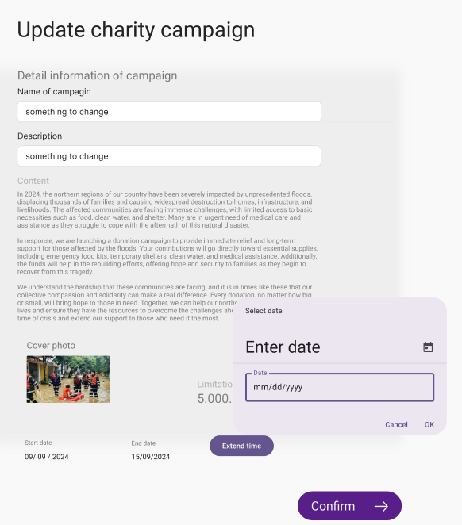

| **Field Name** | **Field Type** | **Description** |
| --- | --- | --- |
| Name of campaign | Text Box | This is for the user to input new campaign name to edit |
| Description | Text Box | This is for the user to input new campaign description to edit |
| Content | Textarea | This is for the user to input new campaign content to edit |
| Cover photo | File select | This is for the user to input new campaign cover photo to edit |
| Limitation | Number | This is for the user to input new campaign limitation to edit |
| Confirm | Button | A button to confirm and update information |
| Extend time | Date selector | This is for user to enter new date and extend the campaign period |

1. **UI Specification**

| Use Case Name | **UC-13_Extend time for campaign**. | | | | |
| --- | --- | --- | --- | --- | --- |
| Primary Actor | Admin | | Secondary Actor: | | Google API |
| Precondition | PRE-1: The user needs to log in the system.  PRE-2: The system has to have existing information of a campaign.  PRE-3: The user accesses this screen through the campaign detail screen. | | | | |
| Postcondition | POST-1: The system will change existing campaign dateline with new date | | | | |
| Description: | The “Extend time for campaign” use case allows users to update and change existing campaigns by their choice with a new dateline. | | | | |
| Normal Flow | **UC-13_Extend time for campaign**. | | | | |
| **Step** | **Actor** | | **System** | |
| **1** | The user log in the system as “Admin” | |  | |
| **2** | The user access update campaign button though campaign detail | | The system redirect up update campaign page | |
| **3** | The user press “Extend” button | | The system will pop up a date select | |
| **4** | The user press “Ok” button | | The system accepts new deadlines for campaigns. | |
| **5** | The user press “Confirm” button | | The system updates new deadlines for campaigns. | |
| Exceptions: | **N/A** | | | | |

* + 1. **UC14: User perspective.**

1. **Screen layout.**

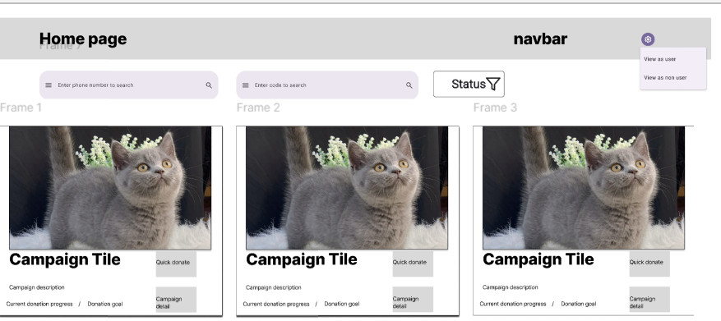

| **Field Name** | **Field Type** | **Description** |
| --- | --- | --- |
| View as user | Button | This will change the screen layout to simulate what information will appear for the user. |
| View as non user | Button | This will change the screen layout to simulate what information will appear for the user. |

1. **UI Specification.**

| Use Case Name | **UC-14_User perspective.** | | | | |
| --- | --- | --- | --- | --- | --- |
| Primary Actor | Admin | | Secondary Actor: | | Google API |
| Precondition | PRE-1: The user needs to log in the system as “Admin”. | | | | |
| Postcondition | POST-1: The system will change UI to simulate user or non user UI. | | | | |
| Description: | The “User perspective” use case allows the admin to clearly see the UI that user and non user be presented with. | | | | |
| Normal Flow | **UC-14_User perspective.** | | | | |
| **Step** | **Actor** | | **System** | |
| **1** | The user log in the system as “Admin” | |  | |
| **2** | The user press profile Icon for more option | | The system will show view as User and non User options | |
| **3** | The user press view as User/Non User | | The system will change the homepage layout to match options. | |
| Exceptions: | **N/A** | | | | |

* + 1. **UC15 : Filter campaign**

1. **screen layout.**

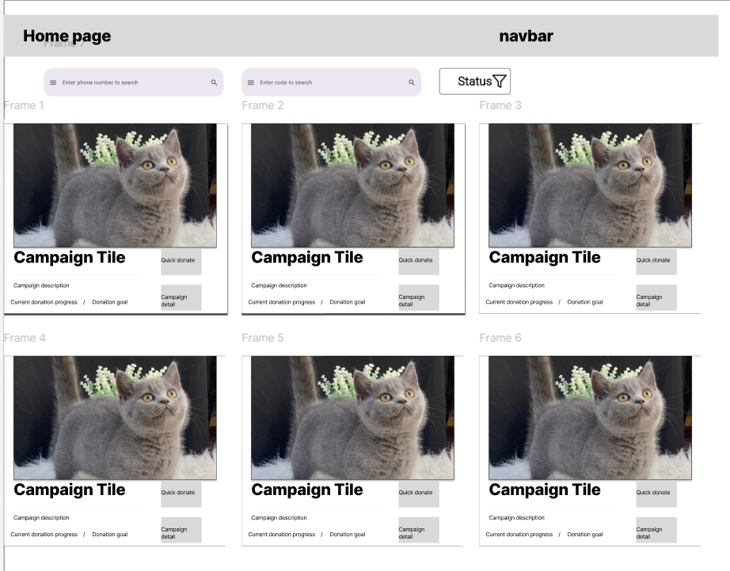

| **Field Name** | **Field Type** | **Description** |
| --- | --- | --- |
| Status | Dropdown button | This will allow users to filter campaigns based on its status. |

1. **UI specification.**

| Use Case Name | **UC-15_Filter campaign.** | | | | |
| --- | --- | --- | --- | --- | --- |
| Primary Actor | Admin,user,non user | | Secondary Actor: | | Google API |
| Precondition | PRE-1: The user needs to access the web homepage. | | | | |
| Postcondition | POST-1: The system will change the campaign list based on user need. | | | | |
| Description: | The “Filter campaign” use case allows the user to filter campaign lists based on status to fit their needs. | | | | |
| Normal Flow | **UC-15_Filter campaign.** | | | | |
| **Step** | **Actor** | | **System** | |
| **1** | The user access the website homepage | |  | |
| **2** | The user press “Status” | | The system will show four choices for users :JustCreate,Donating,DonatingEnd,CampaignClosed. | |
| **3** | The user choose one status | | The system will change the campaign list base on user’s choice. | |
| Exceptions: | **N/A** | | | | |

* + 1. **UC16: View list campagin.**

1. **Screen layout.**

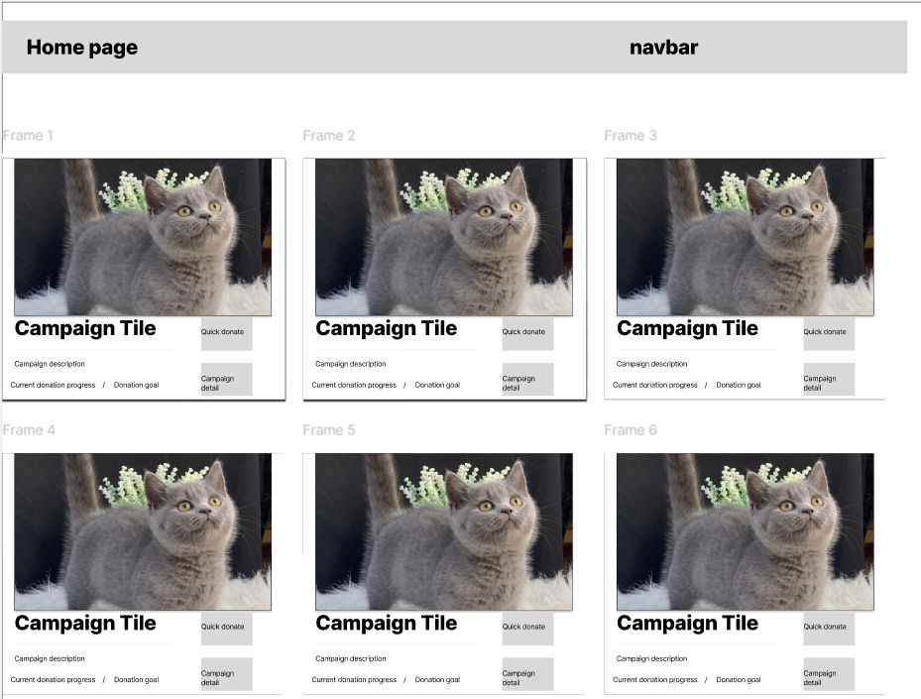

| **Field Name** | **Field Type** | **Description** |
| --- | --- | --- |
| Paging | button | This will allow users to select a new page to view older campaigns which did not appear in the first page. |

1. **UI Specification.**

| Use Case Name | **UC-16_View list campaign.** | | | | |
| --- | --- | --- | --- | --- | --- |
| Primary Actor | Admin,user,non user | | Secondary Actor: | | Google API |
| Precondition | PRE-1: The user needs to access the web homepage. | | | | |
| Postcondition | POST-1: The system will show the campaign list order by campaign’s created date | | | | |
| Description: | The “View list campaign” use case allows the user to view newest campaign lists | | | | |
| Normal Flow | **UC-16_View list campaign.** | | | | |
| **Step** | **Actor** | | **System** | |
| **1** | The user access the website homepage | | The system will display a maximum 20 campaigns ordered by date. | |
|  | **2** | The user press paging button | | The system will display a maximum of 20 campaigns belonging to that page. | |
| Exceptions: | **N/A** | | | | |

* + 1. **UC17: View detail campaign**

1. **Screen Layout**

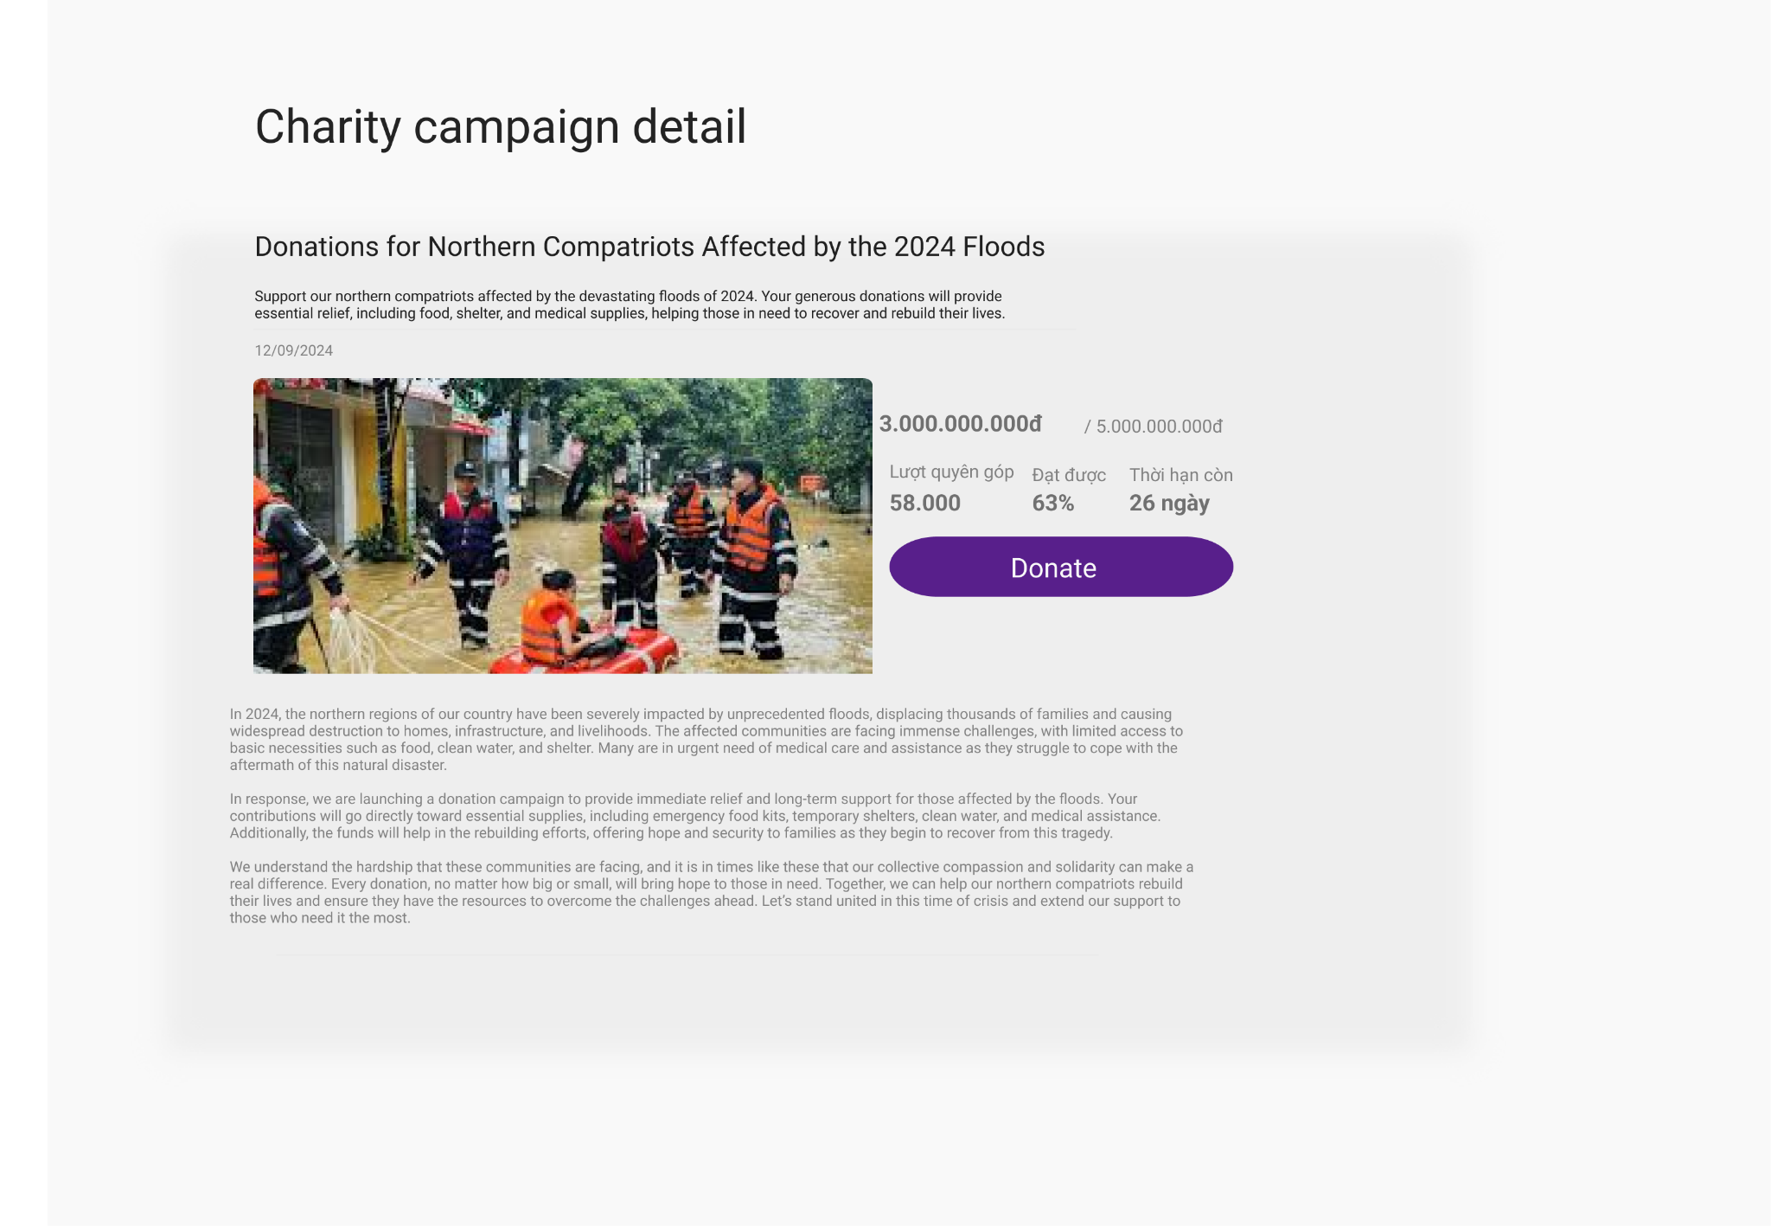

| **Field Name** | **Field Type** | **Description** |
| --- | --- | --- |
| Title | Text | This is the title of a campaign |
| Description | Text | This is the story context of a campaign |
| Content | Text | This is the detail content of a campaign |
| Image | Image | This is the thumbnail image of a campaign |
| Information | Text | This is the donation information |
| Donate | Button | Click this button to show donate form |

1. **UC Specification**

##### 

| Use Case Name | **UC-17_View detail campaign** | | | | |
| --- | --- | --- | --- | --- | --- |
| Primary Actor | All User | | Secondary Actor: | | N/A |
| Precondition | PRE-1: The user needs to access the system. | | | | |
| Postcondition | POST-1: The system displays the detailed information of a charity campaign. | | | | |
| Description: | The “View detail campaign” use case allows user to view detail information of a campaign and make a donation | | | | |
| Normal Flow | **UC-17_View detail campaign** | | | | |
| **Step** | **Actor** | | **System** | |
| **1** | The user clicks on a campaign in Home page | | The system displays a campaign detail page. | |
| Exceptions: | N/A | | | | |

* + 1. **UC18: Donate**

1. **Screen Layout**

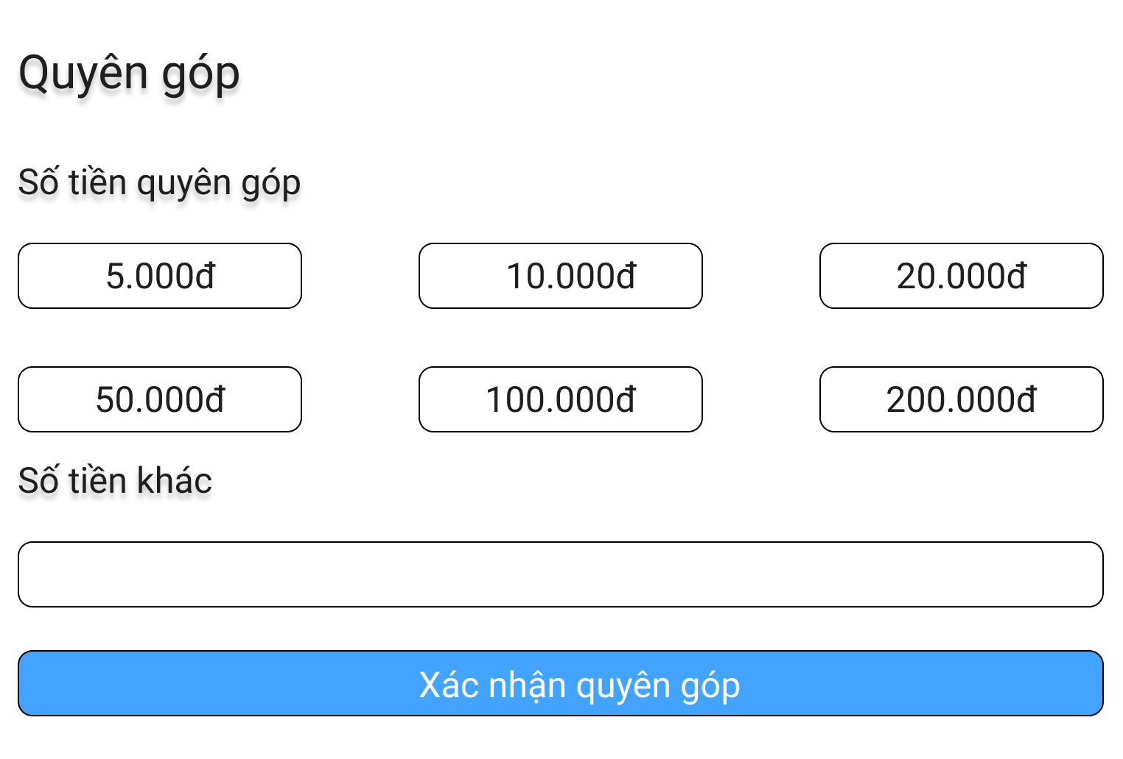

| **Field Name** | **Field Type** | **Description** |
| --- | --- | --- |
| Money Select | Select | This field allows user to select an amount of money to donate |
| Money Input | Input | This field allows user to input an amount of money to donate |
| Donate | Button | This button allows user to confirm donation |

1. **UC Specification**

| Use Case Name | **UC-18_Donate** | | | | |
| --- | --- | --- | --- | --- | --- |
| Primary Actor | User, Non User | | Secondary Actor: | | N/A |
| Precondition | PRE-1: The user needs to access the system. | | | | |
| Postcondition | POST-1: The system displays the detailed information of a charity campaign.  POST-2: The system displays a form and QR code for user to donate | | | | |
| Description: | The “Donate” use case allows user to donate for a campaign | | | | |
| Normal Flow | **UC-18_Donate** | | | | |
| **Step** | **Actor** | | **System** | |
| **1** | The user clicks on a campaign in Home page | | The system displays a campaign detail page. | |
| **2** | The user clicks on donate button | | The system displays a form and QR code | |
| **3** | The user clicks on confirm donate button | | The system display a message of donation status | |
| Exceptions: | N/A | | | | |

* + 1. **UC19: Confirm Donation**

1. **Screen Layout**



| **Field Name** | **Field Type** | **Description** |
| --- | --- | --- |
| Confirm Donation | Button | This button allows user to confirm donation |

1. **UC Specification**

| Use Case Name | **UC-19_Confirm Donation** | | | | |
| --- | --- | --- | --- | --- | --- |
| Primary Actor | User, Non User | | Secondary Actor: | | N/A |
| Precondition | PRE-1: The user needs to access the system.  PRE-2: The user needs to choose an amount of donation | | | | |
| Postcondition | POST-1: The system displays the detailed information of a charity campaign.  POST-2: The system displays a form and QR code for users to donate.  POST-3: The system displays a message of donation status. | | | | |
| Description: | The “Confirm donation” use case allows user to confirm their donation for a campaign | | | | |
| Normal Flow | **UC-19_Confirm Donation** | | | | |
| **Step** | **Actor** | | **System** | |
| **1** | The user clicks on a campaign in Home page | | The system displays a campaign detail page. | |
| **2** | The user clicks on donate button | | The system displays a form and QR code | |
| **3** | The user clicks on confirm donate button | | The system displays a message of donation status | |
| Exceptions: | N/A | | | | |

* + 1. **UC20: View Donator List**

1. **Screen Layout**

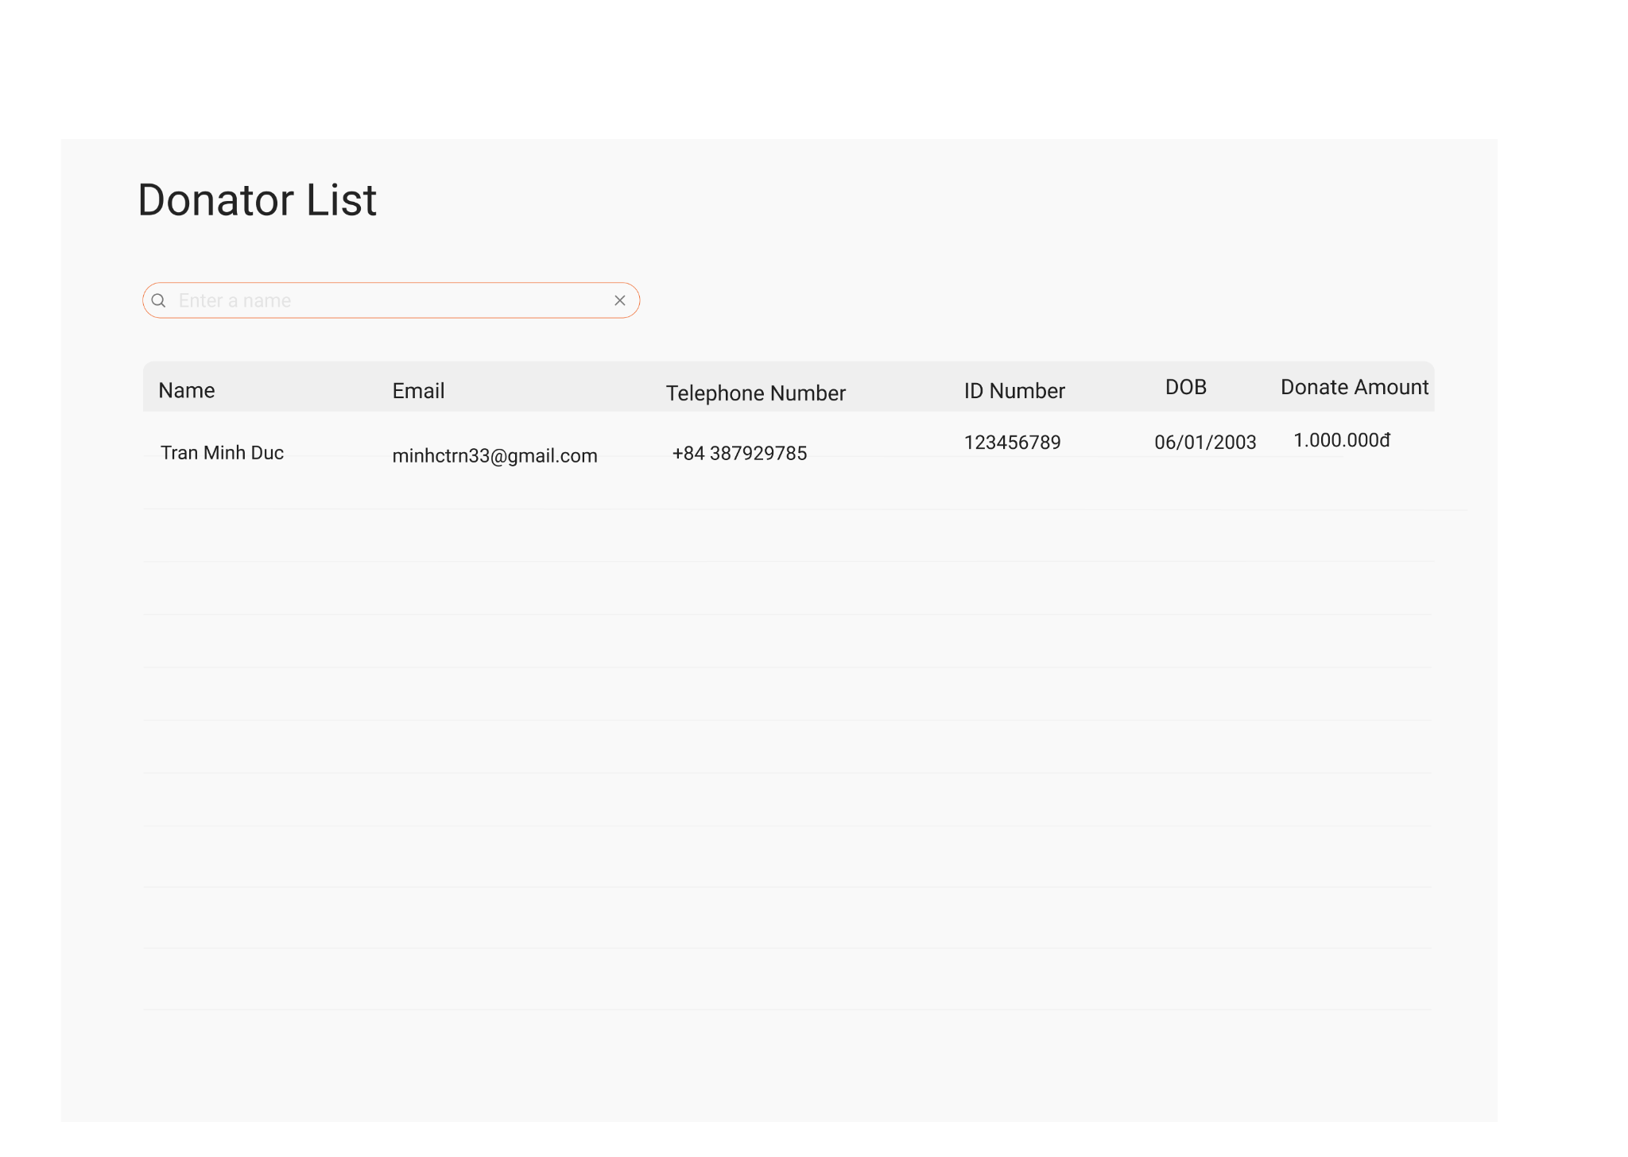

| **Field Name** | **Field Type** | **Description** |
| --- | --- | --- |
| Donator Name | Text | This is the name of donator |
| Money | Text | This is donation amount of a donator |

1. **UC Specification**

| Use Case Name | **UC-20_View Donator List** | | | | |
| --- | --- | --- | --- | --- | --- |
| Primary Actor | User, Non User | | Secondary Actor: | | N/A |
| Precondition | PRE-1: The user needs to access the system.  PRE-2: The user needs to click on a campaign. | | | | |
| Postcondition | POST-1: The system displays the detailed information of a charity campaign.  POST-2: The system displays the donation list of that campaign. | | | | |
| Description: | The “View Donator list” use case allows the user to view the list of donator in a campaign. | | | | |
| Normal Flow | **UC-20_View Donator List** | | | | |
| **Step** | **Actor** | | **System** | |
| **1** | The user clicks on a campaign in Home page | | The system displays a campaign detail page including a donation list of that campaign | |
| Exceptions: | N/A | | | | |

* + 1. **UC21: View Donation History**

1. **Screen Layout**

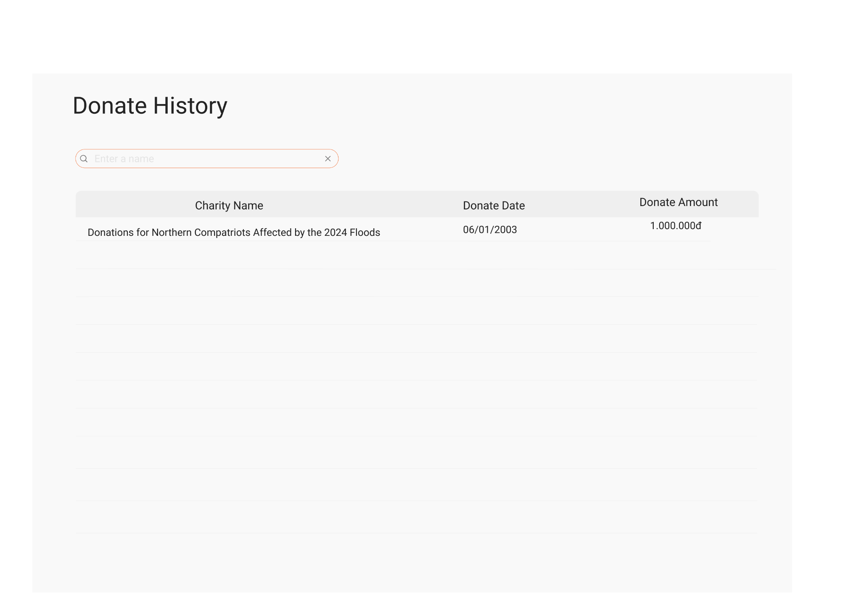

| **Field Name** | **Field Type** | **Description** |
| --- | --- | --- |
| Campaign name | Text | This is the name of a charity campaign |
| Money | Text | This is donation amount of a campaign |

1. **UC Specification**

| Use Case Name | **UC-21_View Donation History** | | | | |
| --- | --- | --- | --- | --- | --- |
| Primary Actor | User | | Secondary Actor: | | N/A |
| Precondition | PRE-1: The user needs to access the system.  PRE-2: The user needs to click on a campaign. | | | | |
| Postcondition | POST-1: The system displays the detailed information of a charity campaign.  POST-2: The system displays the donation list of that campaign. | | | | |
| Description: | The “View Donation History” use case allows the user to view their history of donation | | | | |
| Normal Flow | **UC-21_View Donation History** | | | | |
| **Step** | **Actor** | | **System** | |
| **1** | The user clicks on history in Home page | | The system displays their history of donation. | |
| Exceptions: | N/A | | | | |

* 1. ***Data field valid conditions***

| **#** | **Field Name** | **Mandatory** | **Type** | **Condition** | **Error message** |
| --- | --- | --- | --- | --- | --- |
| 1 | User Name | Y | Text | Max length is 128 |  |
| Value should not be empty | “User Name name should not be empty.” |
| 2 | Password | Y | Text | Max length is 128 |  |
| Value should not be empty | “Password should not be empty.” |
| 3 | New Password | Y | Text | Max length is 128 |  |
| Value should not be empty | “New Password should not be empty.” |
| 4 | Old Password | Y | Text | Max length is 128 |  |
| Value should not be empty | “Old Password should not be empty.” |
| 5 | Confirm New Password | Y | Text | Max length is 128 |  |
| Value should not be empty | “Confirm new password should not be empty.” |
| 6 | User Search Bar | Y | Text | Max length is 128 |  |
| 7 | Campaign Name | Y | Text | Max length is 128 |  |
| Value should not be empty | “Campaign name should not be empty.” |
| 8 | Campaign Description | Y | Text | Max length is 64 |  |
| Value should not be empty | “Campaign Description should not be empty.” |
| 9 | Campaign Content | Y | Text | Max length is 3000 |  |
| Value should not be empty | “Campaign Content should not be empty.” |
| 10 | Photo Url | Y | Text | Max length is 3000 |  |
| Value should not be empty | “Photo Ur should not be empty.” |
| 11 | Limitation | Y | Text | Max length is 64 |  |
| Value should not be empty | “Limitation should not be empty.” |
| 12 | Start Date | Y | DateTime | Value should not be empty | “Start Date should not be empty.” |
| 13 | End Date | Y | DateTime | Value should not be empty | “End Date should not be empty.” |
| 14 | User Search Bar | Y | Text | Max length is 64 |  |
| 15 | Extend Date | Y | DateTime | Min value is EndDate |  |
| Value should not be empty | “Extend date time should not be empty.” |
| 16 | Money | Y | Number | Min value is 5.000 | “Money should not be empty.” “You should donate at least 5000đ” |

1. **NON FUNCTIONAL SPECIFICATION**

* 1. ***Usability***

#### **Look and feel**

The user interface should be simple, intuitive, and visually appealing, adhering to the following guidelines:

* The website should conform to modern web design principles, ensuring accessibility on desktop
* The design should be clean, with a focus on readability and ease of navigation.
* Branding elements such as the logo, colors, and fonts should be consistent across all pages to create a cohesive look and feel.

#### **Screen Styles**

* Screen styles should maintain consistency across all pages to provide a unified experience.
* Elements such as buttons, forms, and navigation menus should be standardized throughout the site.

**4.2 Reliability**

* The website must display suitable user-friendly error messages. Detailed error messages (e.g., stack traces) should not be exposed to end-users.
* Data entered by users (e.g., donation details, contact information) should be validated on the client side and revalidated on the server side to prevent errors and ensure data integrity.

**4.2.1 Availability**

* The website should be available 24/7 with a target uptime of 99.9%.
* Regular backups should be scheduled to minimize data loss in case of unexpected failures.

**4.2.2 System Dependencies**

* Database: MS SQL Server 2021
* Back-end: C#/.NET 8.0
* Front-end: Angular 18.2

**4.2.3 Bugs and Defect Rates**

No specific requirements have been stated. The defect rate objectives can be derived from standards and norms of HVN SDC quality management system.

**4.3 In SDC process, there are four bug severities. Each severity has a weighted value as in table below:**

| **No** | **Bug severity** | **Weighted value** | **Description** |
| --- | --- | --- | --- |
| 1 | Critical | 10 | A major issue where a large piece of functionality or major system component is completely broken  There is no workaround and testing cannot be continued |
| 2 | High | 5 | Major functionality or major system component does not work, works incorrectly or is documented incorrectly  Security issue |
| 3 | Medium | 3 | Minor functionality does not work, works incorrectly or is documented incorrectly |
| 4 | Cosmetic | 1 | Very minor defect, no way to affect the functionality of the product |

Defect rate is measured per Weighted defect / Use case point (Wdef / UCP). The target defect rate should not exceed 3.0 Wdef / UCP.

**4.4 Performance**

**4.4.1 Response time**

* The website should load within 3 seconds on a standard broadband connection.
* Form submissions and data validation should occur within 1 second.
  + 1. **Throughput**

The website should handle up to 100 concurrent users during peak times without performance degradation.

* + 1. **Volume**
* The system must support up to 5 years of historic data, including user transactions, donation records, and event registrations.
* The website is expected to handle between 100-500 active users per month.

**4.5 Supportability**

* All predefined values (e.g., donation amounts, event categories) must be easy to maintain and update through an admin interface.
* The system should provide clear documentation for all functionalities to support future updates and enhancements.

**4.5.1 Error Log**

All log messages must include a standard-format timestamp (YYYY-MM-DD-HH:MM:SS).